SEMI-EMPIRICAL MODELING OF THE LIQUIDUS TEMPERATURE OF BLAST FURNACE SLAG

PATRICK QUEIROZ DOS ANJOS¹, LUCAS DE ALMEIDA QUARESMA², FELIPE FARDIN GRILLO³ e MARCELO LUCAS PEREIRA MACHADO⁴

¹Metallurgical Engineer, M. Eng. Metallurgical and Materials Student at Federal Institute of Espírito Santo (IFES), Vitória-ES, patrick.dosanjos@outlook.com
²Metallurgical Engineer, M. Eng. Metallurgical and Materials Student at Federal Institute of Espírito Santo (IFES), Vitória-ES, lucas.quaresma1@gmail.com
³Dr. Metallurgical Engineering, Professor at Federal Institute of Espírito Santo (IFES), Vitória-ES, felipe.grillo@ifes.edu.br
⁴Dr. Electrical Engineering, Professor at Federal Institute of Espírito Santo (IFES), Vitória-ES, marcelolucas@ifes.edu.br

Apresentado no
Congresso Técnico Científico da Engenharia e da Agronomia – CONTECC
8 a 11 de agosto de 2023

ABSTRACT: The liquidus temperature is an important parameter in the operation of a blast furnace, therefore the knowledge of its mathematical behavior and its modeling are targets of studies. Liquidus temperature data of SiO₂-CaO-Al₂O₃-MgO-TiO₂-K₂O-Na₂O-FeO based slags from the Sciglass database were modeled using artificial neural networks. The best artificial neural network chosen for presenting the lowest loss demonstrate good statistical evaluations. The model deviations and the error by the Monte Carlo method were presented.
KEYWORDS: Liquidus temperature, Slag, Blast furnace, Artificial Neural Networks.

MODELAGEM SEMI-EMPÍRICA DA TEMPERATURA LIQUIDUS DE ESCÓRIAS DE ALTO FORNO

RESUMO: A temperatura liquidus é um parâmetro de importância no funcionamento de um alto forno, consequentemente o conhecimento do seu comportamento matemático e a sua modelagem são alvos de estudos. Dados da temperatura liquidus de escórias baseadas no sistema SiO₂-CaO-Al₂O₃-MgO-TiO₂-K₂O-Na₂O-FeO retirados do banco de dados Sciglass foram modelados através de redes neurais artificiais. A melhor rede neural artificial escolhida por apresentar o menor loss demonstrou boas avaliações estatísticas. Os desvios do modelo e o erro pelo método de Monte Carlo foram apresentados.
PALAVRAS-CHAVE: Temperatura liquidus, Escória, Alto forno, Redes Neurais Artificiais.

INTRODUCTION

The liquidus temperature (T_{liq}) is the temperature at which a material becomes fully liquid (Mills et al., 2016) and is one of the most important physical parameters regarding the crystalline behavior of materials (Ding et al., 2018). In the blast furnace, the liquidus temperature is one of the parameters with high importance (Dong et al., 2019) with an appropriate range for the stability of a blast furnace (Shiau et al., 2018).
A typical composition of blast furnace slags can be seen in Table 1.

Table 1. Typical chemical composition of a blast furnace (Sajid et al., 2019)
Composition | SiO₂ | CaO | Al₂O₃ | MgO | TiO₂ | K₂O | Na₂O | FeO | others
Variation  (%wt) | 30-40 | 34-40 | 10-25 | 5-10 | 0-2 | 0-0,7 | 0-0.3 | 0.1-1.9 | 1-2

Liquidus temperature is directly related to viscosity, as shown in Equation 1 (Seetharaman et al., 2000).

$\frac{1}{R}\frac{∂^{2}Q}{∂T^{2}}=\frac{∂^{2}\left(\frac{∂\text{logη}}{∂T^{−1}}\right)}{∂T^{2}}$ (1)

R is the universal gas constant, Q the activation energy, T the temperature and η the viscosity.
The liquidus temperature has a numerical value greater than the solidification temperature through the supercooling phenomenon in multicomponent materials. Thus, at temperatures between the liquidus temperature and the solidification temperature of the materials, the phenomena of nucleation and recalescence of the formed solids occur (Zhang et al., 2016).
As the liquidus temperature is important for blast furnaces, its behavior and its mathematical modeling have value and a prominent semi-empirical modeling are the artificial neural networks (Kozlov and Tiumentsev, 2019). The present work aims to mathematically model the liquidus temperature of blast furnace slag through artificial neural networks.

MATERIALS AND METHODS

Data of SiO₂-CaO-Al₂O₃-MgO-TiO₂-K₂O-Na₂O-FeO based slags (mass percentage) with each related liquidus temperature (K) were retrieved from the Sciglass database (Cassar, 2021) and subsequently the data were normalized between 0 and 1 to help optimize the mathematical modeling.
Artificial neural networks were built with 1 and 2 hidden layers (Maiorov and Pinkus, 1999) varying the number of neurons considering Equation 2 (Kidger and Lyons, 2020).

w≤d_{x}+d_{y}+1 (2)

w is the number of neurons in each hidden layer, d_{x} is the number of input variables and d_{y} the number of output variables.
The best artificial neural network was considered the one with the lowest loss, computed by the mean squared error (Equation 3) and subsequently statistically evaluated through the metrics of mean absolute error (Equation 4), mean absolute percentage error (Equation 5) and the coefficient of correlation (Equation 6).

$\text{MSE}=\frac{1}{N}\sum{{\left(y_{\text{true}}−y_{\text{pred}\text{.}}\right)}^{2}}$(3)
$\text{MAE}=\frac{1}{N}\sum{\left(\left(y_{\text{true}}−y_{\text{pred}\text{.}}\right)\right)}$(4)
$\text{MAPE}=\frac{1}{N}\sum{\frac{y_{\text{true}}−y_{\text{pred}\text{.}}}{y_{\text{true}}}}$(5)
$p=\frac{\text{Cov}\left(y_{\text{true}}{\text{,y}}_{\text{pred}\text{.}}\right)}{σ\left(y_{\text{true}}\right)σ\left(y_{\text{pred}\text{.}}\right)}$(6)

N is the amount of data, y_{true} the database data, y_{pred.} the data predicted by the artificial neural network, Cov is the covariance and σ the standard deviation.
The deviations of the best artificial neural network (deviation=ytrue-ypred.) were also evaluated to show the variability of the errors and the Monte Carlo method (Metropolis and Ulam, 1959) was applied to see the behavior of the best artificial neural network taking into account consideration data in large quantities (Equation 7).

$M=\frac{1}{N}\sum{\left(X\left(B−A\right)\right)}$(7)

X is a vector, B the maximum and A the minimum value contained in X, respectively, and M is the area between B and A (B>A)

RESULTS E DISCUSSION

189 different chemical composition and liquidus temperature data with 1106.15≤T_{liq}≤1883.15 were used. Considering that d_{x} is equal to 9 (SiO₂-CaO-Al₂O₃-MgO-TiO₂-K₂O-Na₂O-FeO system and the sum of other chemical species) and d_{y} equal to 1 (liquidus temperature), we have the value of w≤11 that was considered a variant in the construction of artificial neural networks, completing a total of 132 different artificial neural networks.
The loss computed by the artificial neural network can be seen in Figure 1.

Figure 1. Loss in each of the 132 different artificial neural networks built for the mathematical modeling of the liquidus temperature of blast furnace slag

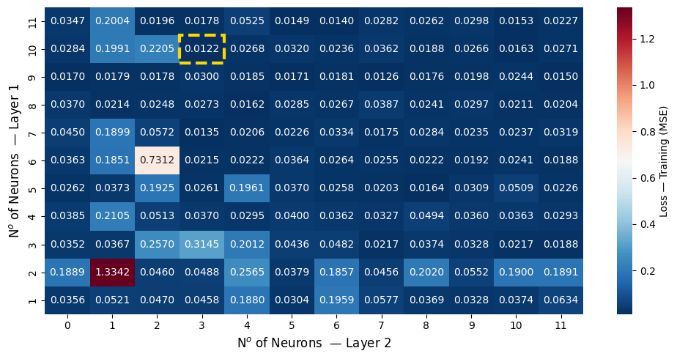
The artificial neural network with the lowest loss had 10 neurons in the first hidden layer and 3 neurons in the second hidden layer (ANN 10-3). MAE, MAPE, and p parameters are shown in Table 2.

Table 2. Statistical evaluation of the ANN 10-3
Statistical Evaluation | MAE (K) | MAPE (%) | p
ANN 10-3 | 24.82 | 1.56 | 0.9712

The relationship between the database data and the data predicted by ANN 10-3 (Figure 2) obtained a correlation considered as strong correlation (Vatcheva et al., 2016), with an average percentage error of less than 2%.

Figure 2. Relationship between database data and data predicted by ANN 10-3 in the prediction of liquidus temperature of blast furnace slag

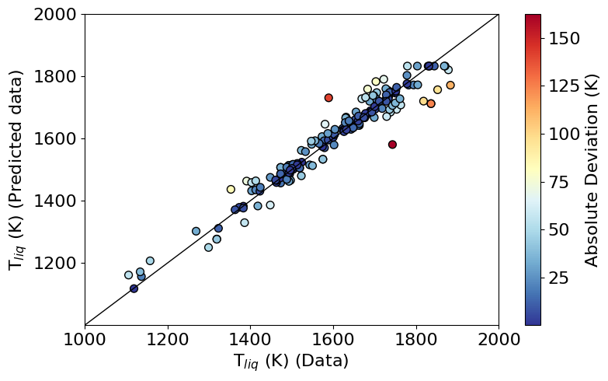
The ANN 10-3 deviations showed variation between the minimum value of -162.51K and the maximum value of 141.54K, but with a percentage amount of 75% of the deviations remained with values between -10.43K and 19.32K, as indicated by Table 3.

Table 3. Statistical evaluation of ANN 10-3 deviations
Deviation (K) | Minimum  (0%) | 25% | 50% | 75% | Maximum  (100%)
ANN 10-3 | -162.51 | -10.43 | 3.18 | 19.32 | 141.54

The Monte Carlo method was applied against the database and against random data with 1000 different data in 1000 different simulations. Applying it to the database data resulted in a value of 1232311.10K² and to the random data a value of 1076727.67K², resulting in a percentage error of approximately 12.63%. This demonstrates that the ANN 10-3 has agreement with the values located between the maximum and minimum of each input variable, denoting a good approximation in different numerical simulations.

CONCLUSION

The liquidus temperature and blast furnace SiO₂-CaO-Al₂O₃-MgO-TiO₂-K₂O-Na₂O-FeO baesd slag were mathematically modeled using artificial neural networks. The best artificial neural network obtained 10 neurons in the first hidden layer and 3 neurons in the second hidden layer, with 9 input variables and 1 output variable (ANN 10-3).
Statistical evaluation showed that the liquidus temperature data taken from the Sciglass database in relation to the predicted data from ANN 10-3 obtained a MAE close to 25K, MAPE with 1.56% and a correlation coefficient of 0.9712, indicating collinearity. The deviations showed an amount between 10.43K and 19.32K in 75% of the data and the Monte Carlo method showed that ANN 10-3 has a good approximation in different numerical simulations.

REFERENCES

Cassar, D. ViscNet: Neural network for predicting the fragility index and the temperature-dependency of viscosity. Acta Materialia, v.206, 116602, 2021.
Ding, B; Wang, W; Zhu, X; He, X-Y; Tan, Y; Liao, Q. Prediction on crystallization behaviors of blast furnace slag in a phase change cooling process with corrected optical basicity. Fuel, v.223, p.360-365, 2018.
Dong, J; Zhang, D; Gan, L. An empirical formula for accurate calculation of liquidus temperature of blast furnace slags in SiO₂-Al₂O₃-CaO-MgO system. Ironmaking & Steelmaking, v.46, n.1, p.71-74, 2019.
Kidger, P; Lyons, T. Universal Approximation with Deep Narrow Networks. Proceedings of Machine Learning Research, v.125, p.1-22, 2020.
Kozlov, D; Tiumentsev, Y. Semi-empirical Neural Network Models of Hypersonic Vehicle 3D-Motion Represented by Index 2 DAE. Advances in Neural Computation, Machine Learning, and Cognitive Research III, Dolgoprudny, Russia, 2019.
Maiorov, V; Pinkus, A. Lower bounds for approximation by MLP neural networks. Neurocomputing, v.25, p.81-91, 1999.
Metropolis, N; Ulam, S. The Monte Carlo Method. Journal of the American Statistical Association, v.44, n.247, p.335-341, 1949.
Mills, K; Karagadde, S; Lee, P; Yuan, L; Shahbazian, F. Calculation of Physical Properties for Use in Models of Continuous Casting Process Part 1 Mould Slags. ISIJ International, v.56. n.2, p.264-273, 2016.
Sajid, M; Bai, C; Aamir, M; You Z; Yan, Z; LV, X. Understanding the Structure and Structural Effects on the Properties of Blast Furnace Slag (BFS). ISIJ International, v.59, n.7, p.1153-1166, 2019.
Seetharaman, S; Sridhar, S; Sichen, D; Mills, K.C. Estimation of Liquidus Temperatures for Multicomponent Silicates from Activation Energies for Viscous Flow. Metallurgical and Materials Transactions B, v.31B, p.111-119, 2000.
Shiau, J; Liu, S; Ho, C. Development of Slag Flowability Prediction Formula for Blast Furnace Operation and Its Application. ISIJ International, v.58, n.1, p.52–59, 2018.
Vatcheva, K; Lee, M; McCormick, J, Rahbar, M. Multicollinearity in Regression Analyses Conducted in Epidemiologic Studies. Epidemiology, v.6, n.2, 227, 2016.
Zhang, Y; Cheng, X; Zhong, H; Xu, Z; Li, L; Gong, Y; Miao, X; Song, C; Zhai, Q. Comparative Study on the Grain Refinement of Al-Si Alloy Solidified under the Impact of Pulsed Electric Current and Travelling Magnetic Field. Metals, v.6, n.7, 170, 2016.

